1. Yellow is the root
2. Magenta, Cyan, orange, white, gray, brown
3. black, white, gray, brown
4. Red
5. Yellow > Blue > Black > Orange
6. 11
7. 4

1. WebServiceResponse, Status, result, type, name, location, lat, lng, result, message
2. Status, type, name, message
3. None
4. 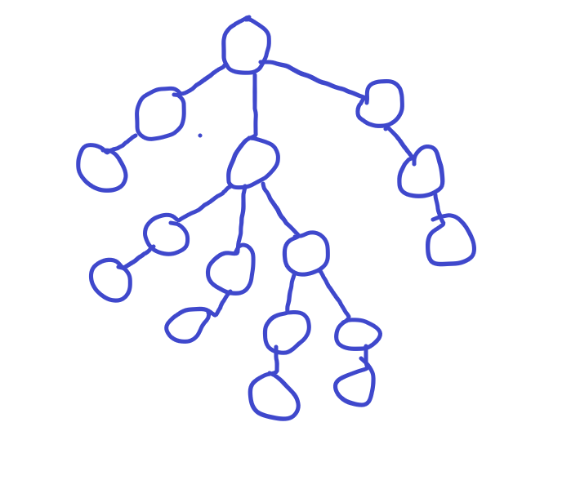
5. Album, release date, and track all have attributes.
6. Album = label > “Sony” released = date > “Oct 25th, 1990” track = number > “1” > duration > “16:29” track = number > “1” > duration > “18:30”
7. .
8. <composer>George Gershwin</composer>
9. <track number="2" duration="18:30">An American in Paris</track>
10. 4
11. 6
12. <title> node
13. Released
14. Number 0 which is track 1 and duration 16:29.
15. George gershwin or it could also be null
16. It would be from album, to tracks, to track, to an american in paris.
17. an american in paris is indexed in 1 and rhapsody in blue is indeed in 0
18. 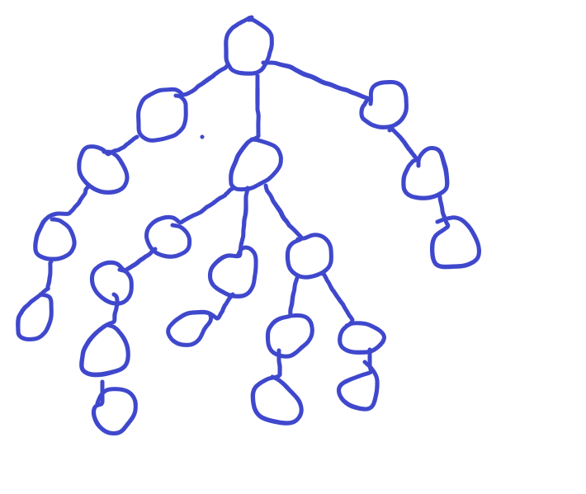
19. <released>Oct 25, 1990</released>
20. Released , oct 25th 1990
21. Weather >( location > (city > (columbus)) > (state > (oh)) > current > forecast
22. <state > OH <City> COLUMBUS </city> </state>
23. <query>
24. 4 attributes
25. Us
26. 1 child
27. 1 child
28. 13 children
29. 0-12
30. 7
31. Country > united states , city > columbus,
32. <geo:lat> 39.98914 <geo:long> -82
33. Query 0,0,12,1,0 query 0,0,12,2,0
34. Weather:forest
35. 7
36. High > 41 code > 28 low > 31
37. 6
38. Qwerty, results, channel, item, geo int, 39.98914
39. (<query> 0, 0, 12, 1, 0)